**Question 1**

**HTML**

<!DOCTYPE html>

<html lang="en">

<head>

    <meta charset="UTF-8">

    <meta name="viewport" content="width=device-width, initial-scale=1.0">

    <title>Css Grid</title>

    <link rel="stylesheet" href="a3_p1.css">

</head>

<body>

    <div class="grid-container">

        <div class="grid-item item-1">1</div>

        <div class="grid-item item-2">2</div>

        <div class="grid-item item-3">3</div>

        <div class="grid-item item-4">4</div>

        <div class="grid-item item-5">5</div>

        <div class="grid-item item-6">6</div>

        <div class="grid-item item-7">7</div>

        <div class="grid-item item-8">8</div>

        <div class="grid-item item-9">9</div>

    </div>

</body>

</html>

**CSS**

body{

    display: flex;

    text-align: center;

    justify-content: center;

    align-items: center;

}

.grid-container{

    display: grid;

    grid-template-columns: repeat(3,150px);

    grid-template-rows: repeat(3,100px);

    margin-top: 60px;

    gap: 5px;

    height: 700px;

    width: 700px;

    justify-content: center;

}

.grid-item{

    display: flex;

    justify-content: center;

    text-align: center;

    align-items: center;

    color: white;

}

.item-1{

    grid-column: 1/2;

    grid-row: 1/2;

    background-color:skyblue;

}

.item-2{

    grid-column: 2/3;

    grid-row: 1/2;

    background-color:red;

}

.item-3{

    grid-column: 3/4;

    grid-row: 1/2;

    background-color:blue;

}

.item-4{

    grid-column: 1/2;

    grid-row: 2/3;

    background-color:yellow;

}

.item-5{

    grid-column: 2/3;

    grid-row: 2/3;

    background-color:blueviolet;

}

.item-6{

    grid-column: 3/4;

    grid-row: 2/3;

    background-color:red;

}

.item-7{

    grid-column: 1/2;

    grid-row: 3/4;

    background-color:orange;

}

.item-8{

    grid-column: 2/3;

    grid-row: 3/4;

    background-color:lightseagreen;

}

.item-9{

    grid-column: 3/4;

    grid-row: 3/4;

    background-color:brown;

}

@media(max-width:658px)

{

    .item-1{

        background-color: aqua;

    }

}

@media(max-width:658px)

{

    .item-2{

        background-color:lightcoral;

    }

}

@media(max-width:658px)

{

    .item-3{

        background-color:darkcyan;

    }

}

@media(max-width:658px)

{

    .item-4{

        background-color:darkorchid;

    }

}

@media(max-width:658px)

{

    .item-5{

        background-color:lightseagreen;

    }

}

@media(max-width:658px)

{

    .item-6{

        background-color: darkmagenta;

    }

}

@media(max-width:658px)

{

    .item-7{

        background-color:darkred;

    }

}

@media(max-width:658px)

{

    .item-8{

        background-color:palevioletred;

    }

}

@media(max-width:658px)

{

    .item-9{

        background-color:burlywood;

    }

}

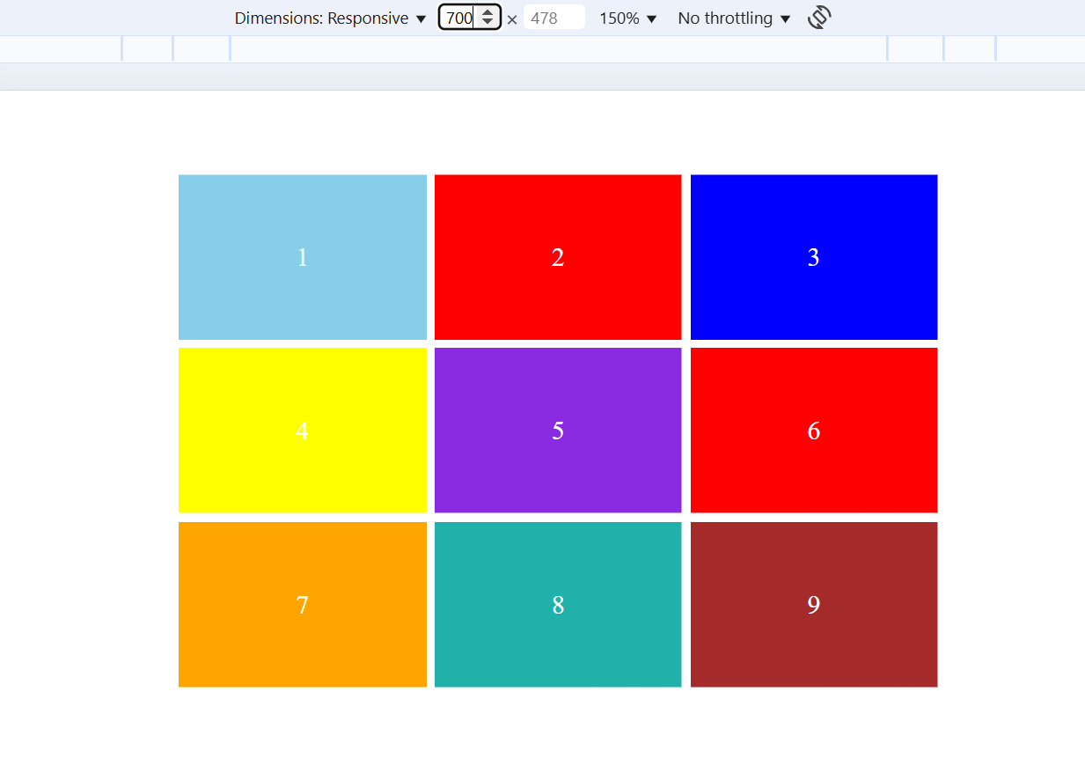

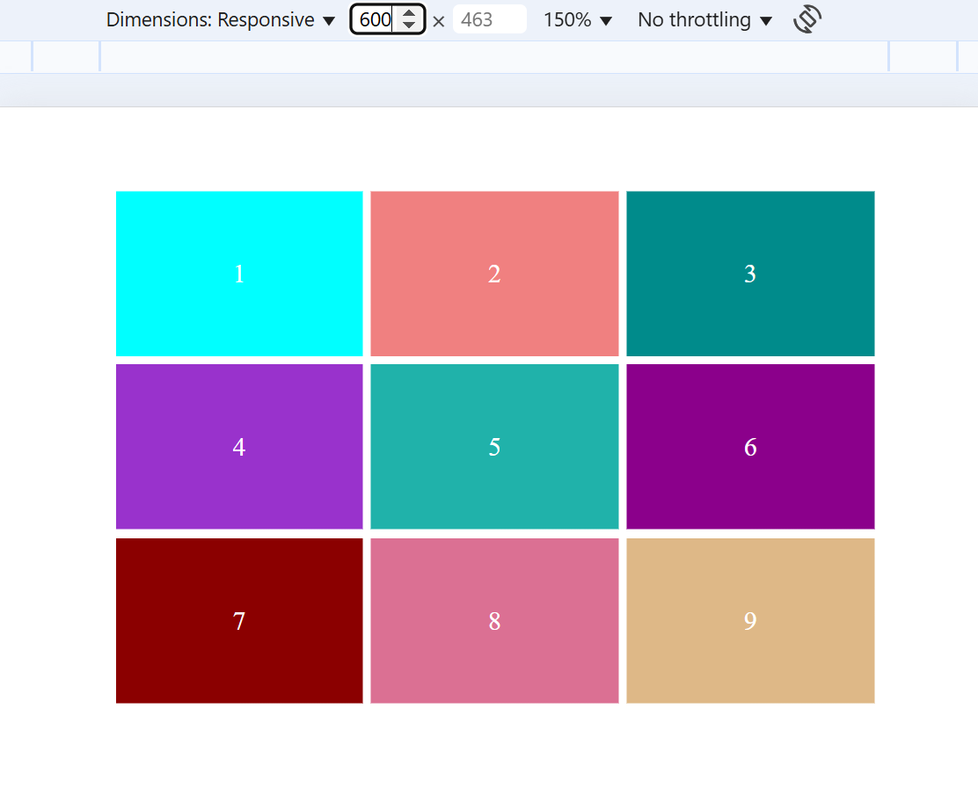

**QUESTION 2**

**HTML**

<!DOCTYPE html>

<html lang="en">

<head>

    <meta charset="UTF-8">

    <meta name="viewport" content="width=device-width, initial-scale=1.0">

    <title>Time Table</title>

</head>

<body>

    <link rel="stylesheet" href="a3_p2.css">

    <h1><center>COLLEGE TIME TABLE</center></h1>

    <table border="2"  align="center">

        <tr align="center">

        <td></td>

        <td>8:30-9:30</td>

        <td>9:30-10:30</td>

        <td>10:30-11:30</td>

        <td>11:30-12:30</td>

        <td>12:30-2:00</td>

        <td>2:00-3:00</td>

        <td>3:00-4:00</td>

        <td>4:00-5:00</td>

        </tr>

        <tr align="center">

            <td>MONDAY</td>

            <td>---</td>

            <td class="sub1">SUB1</td>

            <td class="sub2">SUB2</td>

            <td class="sub3">SUB3</td>

            <td rowspan="6">L <br>U <br>N <br>C <br>H</td>

            <td class="sub4">SUB4</td>

            <td class="sub5">SUB5</td>

            <td><strong>COUNSELLING CALSS</strong></td>

        </tr>

        <tr align="center">

            <td>TUESDAY</td>

            <td class="sub1">SUB1</td>

            <td class="sub2">SUB2</td>

            <td class="sub3">SUB3</td>

            <td>---</td>

            <td class="sub2">SUB2</td>

            <td class="sub2">SUB2</td>

            <td>LIBRARY</td>

        </tr>

        <tr align="center">

            <td>WEDNESDAY</td>

            <td class="sub1">SUB1</td>

            <td class="sub2">SUB2</td>

            <td class="sub5">SWA</td>

            <td>---</td>

            <td colspan="3"><strong>LAB</strong></td>

        </tr>

        <tr align="center">

            <td>THURSDAY</td>

            <td class="sub1">SUB1</td>

            <td class="sub2">SUB2</td>

            <td class="sub3">SUB3</td>

            <td>---</td>

            <td class="sub2">SUB2</td>

            <td class="sub2">SUB2</td>

            <td>LIBRARY</td>

        </tr>

        <tr align="center">

            <td>FRIDAY</td>

            <td class="sub1">SUB1</td>

            <td class="sub2">SUB2</td>

            <td class="sub3">SUB3</td>

            <td>---</td>

            <td class="sub4">SUB4</td>

            <td class="sub5">SUB5</td>

            <td>LIBRARY</td>

        </tr>

        <tr align="center">

            <td>SATURDAY</td>

            <td class="sub1">SUB1</td>

            <td colspan="3"><strong>SEMINAR</strong></STrong></td>

            <td class="sub4">SUB4</td>

            <td class="sub5">SUB5</td>

            <td>LIBRARY</td>

        </tr>

</body>

</html>

**CSS**

.sub1{

    color: blue;

    font-weight: bold;

}

.sub2{

    color:orange;

    font-weight: bold;

}

.sub3{

    color: blueviolet;

    font-weight: bold;

}

.sub4{

    color: green;

    font-weight: bold;

}

.sub5{

    color: red;

    font-weight: bold;

}

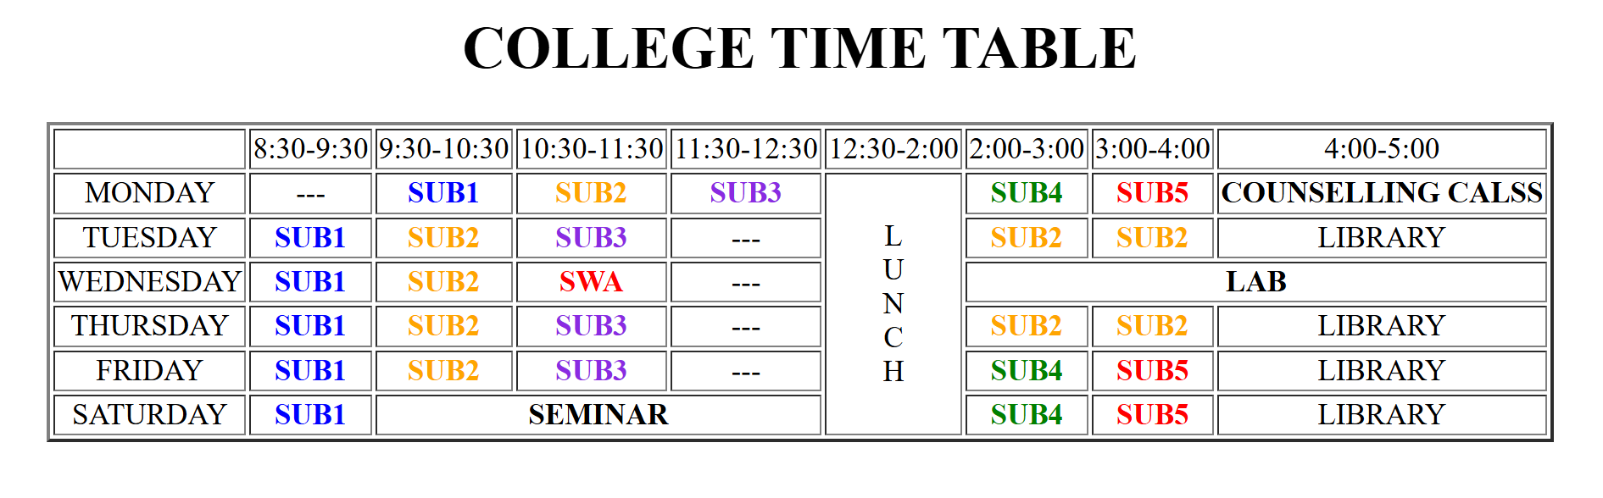

**QUESTION 3**

**HTML**

<!DOCTYPE html>

<html lang="en">

<head>

    <meta charset="UTF-8">

    <meta name="viewport" content="width=device-width, initial-scale=1.0">

    <title>My Time Table</title>

    <link rel="stylesheet" href="a3_p3.css">

</head>

<body>

    <P> <center>My Time Table</center></P>

    <table border="2" align="center">

        <tr>

        <th rowspan="2">Day</th>

        <th colspan="2">Session</th>

        </tr>

        <tr>

        <th>Schedule</th>

        <th>Course Name</th>

        </tr>

        <tr>

            <td>Sunday</td>

            <td>16:00-16:50</td>

            <td>Web Technology</td>

        </tr>

        <tr>

            <td>Sunday</td>

            <td>17:00-17:50</td>

            <td>Network Management</td>

        </tr>

        <tr>

            <td>Monday</td>

            <td>18:00-18:50</td>

            <td>IT Project Management</td>

        </tr>

</body>

</html>



**QUESTION 4**

**HTML**

<!DOCTYPE html>

<html lang="en">

<head>

    <meta charset="UTF-8">

    <meta name="viewport" content="width=device-width, initial-scale=1.0">

    <title>Centeres Box</title>

    <link rel="stylesheet" href="a3_p4.css">

</head>

<body>

    <div class="center-box">

            <h1>Center Box</h1>

            <p>This is a paragraph inside a div.</p>

    </div>

</body>

</html>

**CSS**

body{

    display: flex;

    justify-content:space-around;

    align-items: center;

    height: 100vh;

    margin: 0;

    /*background-color: pink;*/

}

.center-box{

    padding: 20px;

    background-color:palevioletred;

    border: 2px solid black;

}

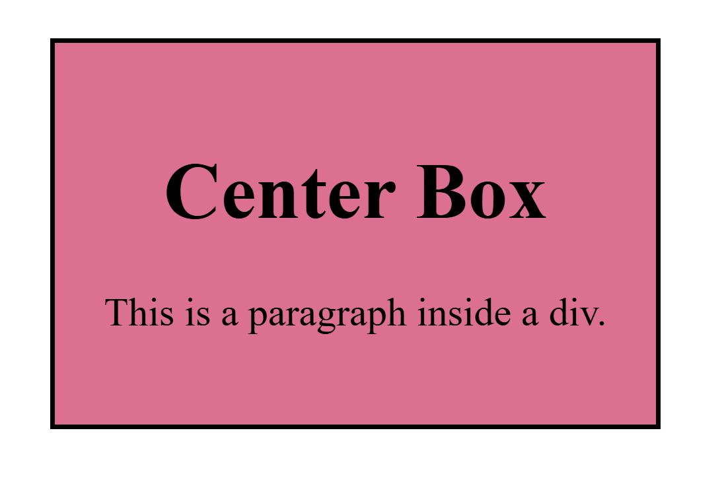

**QUESTION 5**

**HTML**

<!DOCTYPE html>

<html lang="en">

<head>

    <meta charset="UTF-8">

    <meta name="viewport" content="width=device-width, initial-scale=1.0">

    <title>Responsive Navbar</title>

    <link rel="stylesheet" href="a3_p5.css">

</head>

<body>

    <nav>

        <ul>

            <li><a href="#">Home</a></li>

            <li><a href="#">About</a></li>

            <li><a href="#">Services</a></li>

            <li><a href="#">Contact</a></li>

        </ul>

    </nav>

</body>

</html>

**CSS**

*{

    padding: 0;

    margin: 0;

}

nav{

    background-color:#333;

    padding: 15px 0;

}

ul{

    list-style: none;

    display: flex;

    justify-content: space-around;

    align-items: center;

}

li{

    padding: 10px;

}

a{

    text-decoration: none;

    color: white;

    font-size: 18px;

}

a:hover{

    color:palevioletred

}

@media(max-width:600px)

{

    nav{

        background-color:pink;

    }

    a{

        color: #333;

    }

    li{

        padding: 10px 0;

    }

}

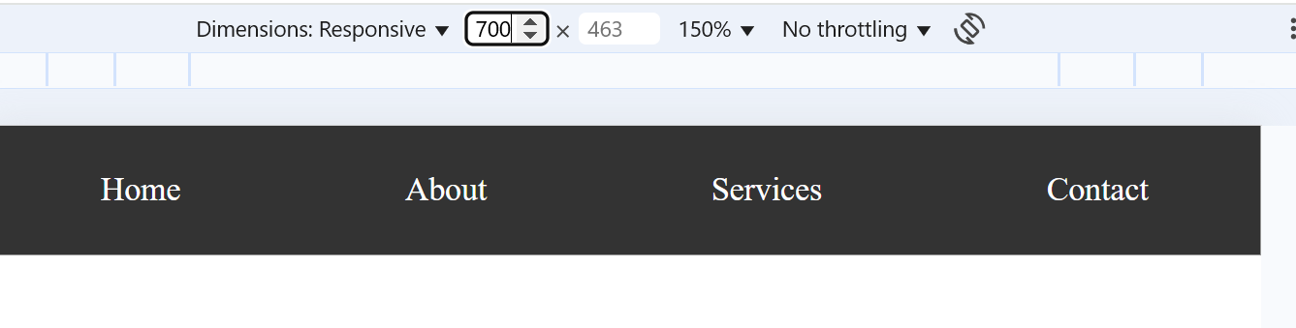

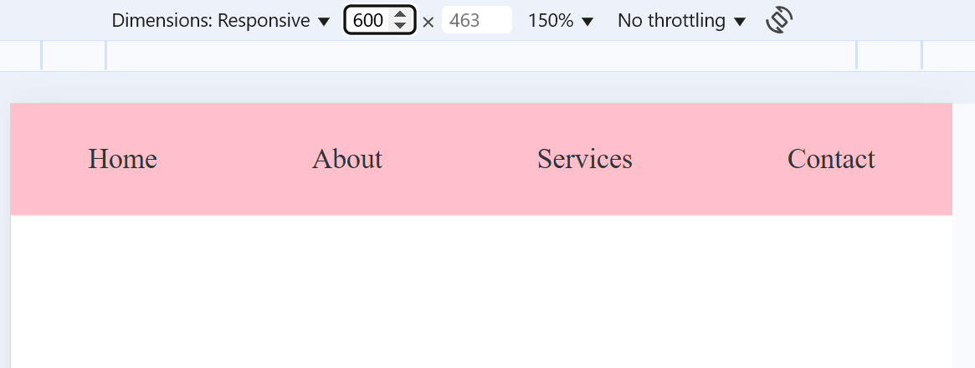

**QUESTION 6**

**HTML**

<!DOCTYPE html>

<html lang="en">

<head>

    <meta charset="UTF-8">

    <meta name="viewport" content="width=device-width, initial-scale=1.0">

    <title>Cards</title>

    <link rel="stylesheet" href="a3_p6.css">

</head>

<body>

    <div class="card-container">

        <div class="card">

            <img src="https://tse2.mm.bing.net/th?id=OIP.gASMlPqsrIt_9q8Y76PZKgHaFj&pid=Api&P=0&h=180" alt="">

            <div class="content">

            <h1>Card 1</h1> <br>

            This is Simple image used to demonstrate text with image in card.

            </div>

        </div>

        <div class="card">

            <img src="http://wonderfulengineering.com/wp-content/uploads/2016/01/nature-wallpapers-38.jpg" alt="">

            <div class="content">

                <h1>Card 2</h1> <br>

                This is Simple image used to demonstrate text with image in card.

            </div>

        </div>

        <div class="card">

            <img src="https://tse1.mm.bing.net/th?id=OIP.q_Ymdfm4iXB_B6Dlqsd09wHaEK&pid=Api&P=0&h=180" alt="">

            <div class="content">

                <h1>Card 3</h1> <br>

                This is Simple image used to demonstrate text with image in card.

            </div>

        </div>

</body>

</html>

**CSS**

<!DOCTYPE html>

<html lang="en">

<head>

    <meta charset="UTF-8">

    <meta name="viewport" content="width=device-width, initial-scale=1.0">

    <title>Cards</title>

    <link rel="stylesheet" href="a3_p6.css">

</head>

<body>

    <div class="card-container">

        <div class="card">

            <img src="https://tse2.mm.bing.net/th?id=OIP.gASMlPqsrIt_9q8Y76PZKgHaFj&pid=Api&P=0&h=180" alt="">

            <div class="content">

            <h1>Card 1</h1> <br>

            This is Simple image used to demonstrate text with image in card.

            </div>

        </div>

        <div class="card">

            <img src="http://wonderfulengineering.com/wp-content/uploads/2016/01/nature-wallpapers-38.jpg" alt="">

            <div class="content">

                <h1>Card 2</h1> <br>

                This is Simple image used to demonstrate text with image in card.

            </div>

        </div>

        <div class="card">

            <img src="https://tse1.mm.bing.net/th?id=OIP.q_Ymdfm4iXB_B6Dlqsd09wHaEK&pid=Api&P=0&h=180" alt="">

            <div class="content">

                <h1>Card 3</h1> <br>

                This is Simple image used to demonstrate text with image in card.

            </div>

        </div>

</body>

</html>

